**TRINITY COLLEGE**

**BUSINESS SCHOOL**

**Discrete Software Publication:   
R Program "Report_Generator"**

By

José Ramón Cobos Cuesta

Supervisor: Dr. Nicholas Danks

**MSc. Business Analytics 2023**

Submitted in partial fulfillment of the requirements of the examination for MSc Business Analytics, Trinity College Dublin, July 2022.

**Author’s declaration**

I have read the University’s code of practice on plagiarism. I hereby certify this material, which I now submit for assessment on the program of study leading to the award of MSc Business Analytics is entirely my work and has not been taken from the work of others, save and to the extent that such work has been cited within the text of my work.

Student Name: José Ramón Cobos

Student ID number: 22326199

Student Signature:

Date: 13th July 2023

**Abstract**

This dissertation describes the development of an automated solution for generating monthly investment reports using an R Markdown template and parameterized execution. The primary objective of this project was to streamline the report generation process by eliminating manual effort and improving efficiency in investment analysis and reporting.

The core component of this solution is an R Markdown file, which serves as a flexible and customizable report template. The template incorporates narrative text, code snippets, and visualizations to create professional-grade investment reports. By leveraging the dynamic document generation capabilities of R Markdown, the template enables the seamless integration of data and analysis results into the report structure. This ensures consistency across multiple reporting periods and allows for effortless updates as new data becomes available.

To automate the generation of reports with variable information, a separate .R file was developed. This file contains a loop that executes the R Markdown template multiple times, each time with a different investor identifier parameter. By modifying the input parameters, the loop generates individualized reports for each. This parameterized execution capability increases the versatility of the solution and the efficiency in generating this type of informative documentation.

The dissertation presents the design and implementation details of the R Markdown template and the parameterized execution loop. Practical examples and real use cases are shown to illustrate the effectiveness and efficiency of the automated report-generation process. In addition, the thesis discusses the advantages of using R Markdown for report creation, including its compatibility with various data formats, its ability to handle complex calculations, and its support for reproducibility and version control.

An evaluation of the performance, usability, and impact of the automated solution on the efficiency of report generation is provided, highlighting the time savings and reduction in manual errors achieved through automation. The thesis also explores possible future enhancements, such as the incorporation of advanced data visualization techniques, the integration of additional data sources, the ability to create flexible reports, which are better adapted to the user's needs, or the extension to generate reports in different formats or languages.

In summary, this thesis presents an automated solution for generating investment reports using an R Markdown template and parameterized execution. By combining the flexibility of the template with the ability to dynamically generate reports with variable inputs, this project contributes to the advancement of investment analysis and reporting practices. The solution improves productivity, reduces manual effort, and enables professionals to focus on interpreting and effectively communicating investment insights.

**Acknowledgments**

First of all, I would like to express my deepest gratitude to my family and my girlfriend and dedicate this thesis to them for everything they have done for me. They have always supported me and pushed me to be a better person and to continue my academic career to the point where I am now, no matter the situation they have always believed in me and have been there to alleviate my problems and make my way easier.

Also, I am so grateful to all my friends, who, although, unlike my parents, have increased the problems, and made my academic career somewhat more complicated than it would have been, they have also believed in me and supported me at times when I needed them. Special mention to the groups "Guapos, Listos y Lucas", "Asuntillos legales" and "Encontrar al cubano".

I would also like to say that I am very proud to have been part of the second promotion of the MSc. Business Analytics at Trinity College Dublin and to have shared time and space with my intelligent and highly qualified professors. Many thanks to the MSc. Business Analytics 22/23 and especially to my great friends from the course for sticking together and having an amazing, happy, and rememberable year.

"Last but not least, I wanna thank me, I wanna thank me for believing in me, I wanna thank me for doing all this hard work, I wanna thank me for having no days off, I wanna thank me for never quitting, I wanna thank me for always being a giver and tryna give more than I receive, I wanna thank me for tryna do more right than wrong, I wanna thank me for just being me at all times… RialPepe”.

**Table of contents**

**Chapter 1 Introduction _____________________________________________ 7**

Section 1.1 Background ________________________________________ 7

Section 1.2 Problem Statement ___________________________________ 8

Section 1.3 Objectives _________________________________________ 9

**Chapter 2 Theoretical Framework ____________________________________ 9**

Section 2.1 Overview of Investment Analysis and Reporting ___________ 9

Section 2.2 Manual Report Generation Challenges ___________________ 10

Section 2.3 Automation in Investment Reporting ____________________ 11

Section 2.4 R Markdown and its Application in Reporting _____________ 12

Section 2.5 Existing Solutions and Tools ___________________________ 13

**Chapter 3 Methodology _____________________________________________ 15**

Section 3.1 Design and Architecture of the Automated Solution ________ 15

Section 3.2 R Markdown Template Development ___________________ 15

Section 3.2.1 Load the necessary packages __________________ 15

Section 3.2.2 Data Input _________________________________ 17

Section 3.2.3 Cover Page ________________________________ 17

Section 3.2.4 Executive Summary _________________________ 18

Section 3.2.5 Investment Overview ________________________ 20

Section 3.2.6 Investment Per Asset – Detailed Historical Data ___ 20

Section 3.3 Parameterized Execution Loop ________________________ 21

**Chapter 4 Future Enhancements and Challenges _______________________ 23**

Section 4.1 Identified Limitations and Challenges ___________________ 23

Section 4.2 Potential Future Enhancements ________________________ 24

Section 4.3 Advanced Data Visualization Techniques ________________ 25

**Chapter 5 User Guidance __________________________________________ 27**

**Bibliography _____________________________________________________ 29**

**List of Figures**

Figure 1: Packages Loaded ……………………………………………………… 15

Figure 2: Cover Page ………………...………….………………………………. 17

Figure 3: Investment Summary …………………………………………………. 19

Figure 4: Portfolio Holdings …………….………………………………………. 19

Figure 5: Investment Overview …………………………………………………. 20

Figure 6: Investment Per Asset …………………………………………….……. 21

**List of Tables**

Table 1: Investors Sheet …………………………………..…………….………. 27

Table 2: TotalBalance Sheet …………………………………….………………. 27

**Chapter 1 Introduction**

**Section 1.1 Background**

In the field of capital management, the generation of investment reports plays a critical role in providing valuable insights to investors and facilitating informed decision-making as can be seen in the article by (True Tamplin, 2023). Capital managers are tasked with analyzing investment portfolios, monitoring performance, and communicating the results to clients regularly. However, the manual process of report generation can be time-consuming, prone to errors, and lacking in efficiency.

The advancement of technology and the availability of programming languages have opened up new possibilities for automating various tasks, including investment reporting “Intelligent automation is revolutionising the business landscape and leading organisations looking to gain sustained advantage have learnt that automisation is a powerful way to reduce costs along that path while improving controls, quality and scalability.”, (Voon Hoe Chen & Phaik Sin Tay, 2023). Recognizing the need to streamline the report generation process, this thesis presents the development of an R program specifically designed to automatically generate quarterly reports for capital managers.

The manual generation of investment reports is burdened by challenges such as data collection from multiple sources, data processing and analysis, and the repetitive nature of report creation. These challenges can lead to inconsistencies, errors, and a significant amount of time spent on non-value-added tasks. Automation offers a solution to these issues by leveraging programming capabilities to streamline the process, reduce errors, and improve efficiency.

As they explain (Wickham, H., & Grolemund, G, 2017), R Markdown is an open-source markup language, it provides a flexible framework for creating dynamic reports that seamlessly integrate narrative text, code, and visualizations. Its dynamic document generation capabilities make it an ideal platform for automating investment reporting. By combining R Markdown with parameterized execution, the developed R program allows for the generation of individualized reports for different investors based on specific input parameters.

The primary objective of this research is to provide capital managers with an automated solution that improves the efficiency and accuracy of investment report generation. By leveraging the power of R Markdown and the developed R program, capital managers can streamline the process, reduce manual effort, and ensure consistency across multiple reporting periods.

This thesis aims to explore the design, implementation, and evaluation of the R program for automated quarterly report generation. It investigates the effectiveness of the solution in terms of performance, usability, and its impact on efficiency and error reduction. The thesis also explores potential future enhancements, such as incorporating advanced data visualization techniques, integrating additional data sources, and enabling user-customized and flexible reports.

The research presented in this thesis contributes to the advancement of capital management practices by providing capital managers with a powerful tool to automate investment reporting. The automated solution improves productivity, reduces manual effort, and enables professionals to focus on interpreting and effectively communicating investment insights to their clients. The findings and insights gained from this research have practical implications for the field of capital management and provide a foundation for further exploration and development in automated reporting techniques.

**Section 1.2 Problem Statement**

In the article written by (Zvi Korn, 2023) it can be deduced that the manual process of generating investment reports for capital managers is riddled with various challenges and limitations that hinder efficiency, accuracy, and productivity. These challenges include:

1. Time-consuming and repetitive tasks: Capital managers spend a significant amount of time collecting data from multiple sources, performing calculations, and formatting reports. This manual effort is not only time-consuming but also increases the risk of errors and inconsistencies across reports.
2. Lack of scalability: As the number of clients and investment portfolios grows, the manual generation of reports becomes increasingly challenging to manage. The process becomes labor-intensive and prone to delays, potentially resulting in outdated and less relevant information for clients.
3. Inconsistencies and human errors: Manual report generation often leads to inconsistencies in formatting, language, and presentation across different reports. Furthermore, the risk of human errors, such as data entry mistakes or formula errors, is significant, which can undermine the credibility and reliability of the reports.
4. Limited customization and flexibility: Manual report generation restricts the ability to customize and tailor reports according to the specific needs and preferences of individual investors. This limitation can hinder effective communication and may fail to address unique client requirements.
5. Cumbersome data integration and analysis: Capital managers face challenges in integrating data from various sources and performing complex calculations and analysis within the report generation process. The manual nature of these tasks can impede timely and accurate data processing and analysis.
6. Lack of version control and reproducibility: With manual processes, tracking changes, maintaining version control, and ensuring the reproducibility of reports becomes difficult. This limitation hampers transparency, audibility, and the ability to revisit and update reports when new data becomes available.

To address these challenges and improve the efficiency, accuracy, and effectiveness of investment report generation, there is a need for an automated solution that streamlines the process, reduces manual effort, ensures consistency, and provides customization and flexibility.

**Section 1.3 Objectives**

The primary objective of this thesis is to develop an R program that automates the generation of quarterly investment reports for capital managers. To accomplish this overarching goal, the specific objectives of this research are, as explained by (R on Curious Joe, 2020):

Design and develop an R Markdown template: Create a flexible and customizable R Markdown template that serves as the foundation for generating investment reports. The template should incorporate narrative text, code snippets, and visualizations to create professional-grade reports.

Implement parameterized execution: Develop a parameterized execution loop that enables the generation of individualized reports for different investors based on specified input parameters. The loop should execute the R Markdown template multiple times, each time with a different investor identifier parameter.

Streamline data integration and analysis: Integrate tools and technologies within the automated solution to efficiently handle data collection, integration, processing, and complex calculations. Enable seamless integration of data and analysis results into the report structure.

Ensure customization and flexibility: Enable capital managers to customize and tailor reports according to the specific requirements and preferences of individual investors. Provide options for including additional data sources, advanced data visualizations, and user-defined report elements.

**Chapter 2 Theoretical Framework.**

**Section 2.1 Overview of Investment Analysis and Reporting**

Investment analysis and reporting are fundamental components of capital management practices. This section provides an overview of the key concepts and approaches in investment analysis and reporting, highlighting their significance in the decision-making process.

According to the article written by (Alexandra Twin, 2022), investment analysis involves evaluating various investment opportunities to determine their potential risks and returns. It encompasses different aspects such as financial statement analysis, market research, and portfolio management techniques. Through investment analysis, capital managers gain insights into the performance of investments, identify trends, and make informed decisions regarding asset allocation and investment strategies.

Investment reporting, on the other hand, involves communicating the results of investment analysis to stakeholders, including clients, shareholders, and regulatory bodies. Reports provide a comprehensive summary of investment performance, risk assessment, and portfolio composition. They enable capital managers to present investment insights, explain investment strategies, and justify investment decisions.

Accurate and timely investment analysis and reporting are crucial for decision-making in capital management. Reliable investment reports provide capital managers with the necessary information to effectively communicate investment performance, risks, and prospects to clients. These reports play a vital role in building trust, attracting new investors, and maintaining existing client relationships.

The literature on investment analysis and reporting highlights the importance of utilizing efficient and effective methodologies and tools to streamline the process. Automating investment reporting can significantly enhance the efficiency, accuracy, and scalability of generating investment reports.

**Section 2.2 Manual Report Generation Challenges**

In addition to the problems mentioned in point 1.2 Problem statement, the manual generation of this type of document entails other problems such as:

1. Data validation and cleansing: Manual report generation often involves collecting data from multiple sources, which can introduce data quality issues such as missing values, inconsistencies, and formatting errors. Capital managers face the challenge of validating and cleansing the data manually, which is time-consuming and increases the risk of errors in the reporting process.
2. Report customization complexity: Meeting the diverse needs and preferences of individual investors through manual report generation can be complex. Capital managers may struggle to incorporate customized elements, such as specific visualizations, investment narratives, or personalized benchmarks, within the reports. The lack of automated tools and standardized processes for customization limits the flexibility and efficiency of the manual reporting workflow.
3. Compliance and regulatory requirements: Investment reports often need to adhere to specific compliance and regulatory guidelines, which can vary across jurisdictions. Manual report generation makes it challenging to ensure consistent compliance with these requirements. Capital managers must invest significant time and effort to stay updated on regulatory changes and manually implement them in the reporting process, increasing the risk of non-compliance.
4. Collaboration and version control: Manual report generation often involves multiple individuals working on different sections or components of the report. Coordinating the efforts of team members, managing updates, and maintaining

version control becomes challenging without a standardized and automated system. This lack of collaboration and version control capabilities can lead to inconsistencies, errors, and difficulties in tracking changes or revisiting previous versions of the report.

1. Limited data analysis capabilities: Manual report generation can restrict the depth and complexity of data analysis performed within the reporting process. Capital managers may face challenges in performing advanced calculations, conducting statistical analyses, or generating interactive visualizations manually. This limitation hampers the ability to derive meaningful insights and present them effectively in the reports.

Addressing these challenges requires an automated solution that can streamline the reporting process, enhance customization capabilities, ensure compliance with regulations, improve scalability and productivity, facilitate collaboration and version control, and enable advanced data analysis.

**Section 2.3 Automation in Investment Reporting**

Automation has transformed the landscape of investment by offering a lot of benefits that have revolutionized the decision-making process and improved investment outcomes. As explained in this article (Jeanne Boillet, 2020) in recent years, rapid advancements in artificial intelligence, machine learning, and data analytics have given rise to sophisticated automation tools that have made investment reports more efficient, accurate, and insightful than ever before.

Traditionally, the process of creating investment reports was a manual and time-consuming task. Analysts would spend countless hours gathering data from various sources, analyzing market trends, and constructing comprehensive reports. However, with automation, these arduous tasks have been significantly streamlined. Automation tools enable investment professionals to access up-to-date and comprehensive information promptly.

As mentioned in the article (Clare McKinley, 2022) one of the significant advantages of automation in investment reports is its ability to reduce human errors. Manual data entry and calculation can be prone to mistakes, which can have severe consequences for investment decisions. By automating these processes, the risk of human error is greatly reduced, ensuring the accuracy and reliability of the information presented in investment reports. This, in turn, allows investors to make more informed decisions based on trustworthy data, leading to improved investment performance.

Furthermore, automation enables real-time monitoring of market trends and portfolio performance, providing investors with timely insights that are crucial for successful investment strategies. Automation tools can continuously track and analyze market conditions, identifying patterns, correlations, and potential risks. This real-time

monitoring capability allows investors to adjust their portfolios promptly, seize opportunities, and mitigate potential losses.

In addition to data analysis, automation in investment reports can also assist in generating personalized reports tailored to individual investor preferences. Automation tools can customize reports by incorporating specific metrics, benchmarks, and investment goals, ensuring that investors receive information that is relevant and meaningful to their unique circumstances. This level of personalization enhances the decision-making process by providing investors with actionable insights aligned with their specific investment objectives.

As automation technology continues to evolve, its integration into investment reports holds even greater promise. Advancements in natural language processing and machine learning algorithms can further enhance the capabilities of automation tools, enabling them to identify and extract relevant insights from unstructured data sources such as news articles, social media sentiment, and analyst reports. This integration of automation with advanced analytics has the potential to unlock valuable insights that were previously difficult to access, providing investors with a competitive edge in the market.

**Section 2.4 R Markdown and its Application in Reporting**

The article (Garrett Grolemund, 2014) explains perfectly what R Markdown is and how to use it, and by reading it you can fully understand why R Markdown is and how to use it, Markdown has emerged as a popular formatting language that has found wide application in reporting, providing a simple yet powerful tool for creating clear and visually appealing documents. With its lightweight syntax and ease of use, Markdown has become a go-to choice for individuals and organizations looking to streamline their reporting processes and enhance readability.

One of the primary advantages of Markdown in reporting is its simplicity. The syntax is straightforward and intuitive, making it accessible to both technical and non-technical users. Unlike complex formatting languages, Markdown requires minimal effort to learn and implement, allowing report creators to focus more on the content rather than getting caught up in formatting intricacies. This simplicity also promotes consistency across reports, as the basic syntax remains the same, regardless of the complexity of the document.

Markdown's versatility is another significant factor driving its application in reporting. It supports various elements, such as headings, lists, tables, images, links, and code blocks, enabling report creators to structure and present information in a clear and organized manner. The ability to easily create tables, for example, is particularly valuable when presenting data-driven information or financial analysis in reports. Markdown's support for code blocks is also beneficial when including snippets of programming code or technical explanations in reports.

Furthermore, Markdown allows for seamless integration with other tools and platforms, enhancing the collaborative nature of reporting. Many text editors, note-taking

applications, and content management systems support Markdown, making it easy to create, edit, and share reports across different devices and software environments. This flexibility enables individuals and teams to collaborate more efficiently, as Markdown documents can be easily version-controlled, shared, and tracked using popular collaboration tools like Git.

Markdown's compatibility with HTML is another advantage that contributes to its application in reporting. While Markdown provides a simplified and human-readable syntax, it can also incorporate HTML elements for more advanced formatting options. This compatibility allows users to leverage the power of HTML when needed, such as embedding multimedia content, creating complex layouts, or adding custom styling to reports. The seamless transition between Markdown and HTML provides users with greater flexibility in designing and customizing their reports according to specific requirements.

Additionally, Markdown's plain-text nature ensures that reports are easily readable and editable across different platforms and devices. Reports created in Markdown can be converted to various formats such as PDF, HTML, or Word, allowing for easy distribution and sharing with stakeholders who may prefer different file formats. The ability to generate multiple output formats from a single Markdown source simplifies the process of adapting reports to different audiences and ensures consistent formatting and content across various channels.

**Section 2.5 Existing Solutions and Tools**

In the realm of automation in investment reports, a variety of existing solutions and tools have emerged to streamline and enhance the reporting process. These solutions leverage advanced technologies such as artificial intelligence, machine learning, and data analytics to automate data collection, analysis, and presentation, empowering investors with efficient and accurate reporting capabilities.

One of the key areas where automation tools excel is data aggregation. Existing solutions utilize robust algorithms to collect data from multiple sources, including financial databases, market APIs, news feeds, and social media platforms. This automated data gathering eliminates the need for manual data entry and significantly reduces the time and effort required to compile comprehensive investment reports. These tools can seamlessly integrate with various data providers, ensuring that investors have access to real-time and reliable information to make informed decisions.

Once the data is collected, automation tools employ advanced analytical techniques to extract meaningful insights and identify relevant trends. Machine learning algorithms can analyze large datasets, identify patterns, and generate valuable predictions or recommendations. By automating the analytical process, these tools enhance the accuracy and efficiency of investment reports, providing investors with actionable information to optimize their investment strategies.

Visualization is another crucial aspect of investment reporting, and existing solutions offer sophisticated tools to present data in a clear and visually appealing manner. These tools provide a wide range of customizable templates, charts, and graphs, enabling investors to present complex information in a visually digestible format. Visualization capabilities not only enhance the readability and understanding of investment reports but also facilitate effective communication with stakeholders, enabling investors to convey their findings and recommendations with clarity and impact.

Moreover, automation solutions in investment reporting often include customizable reporting frameworks. Investors can set up automated reporting schedules, ensuring that reports are generated and delivered at predefined intervals.

Furthermore, automation tools in investment reporting frequently incorporate collaboration features, enabling multiple stakeholders to collaborate seamlessly on reports. These tools often have functionalities for version control, commenting, and document sharing, facilitating efficient collaboration among investment teams, analysts, and clients. The ability to collaborate in real-time and track changes ensures that investment reports are accurate, up-to-date, and reflect the collective expertise and insights of the involved parties.

As automation technology continues to advance, existing solutions for investment report automation are likely to integrate more advanced features. These may include natural language processing for automated report generation, sentiment analysis to gauge market sentiment, and advanced predictive analytics for improved forecasting. Additionally, integration with cloud platforms and APIs can further enhance the scalability, accessibility, and integration capabilities of these tools.

**Chapter 3 Methodology**

**Section 3.1 Design and Architecture of the Automated Solution**

The development of the R program for automated quarterly report generation has followed a structured methodology to ensure a systematic and effective approach. This section outlines the methodology employed in designing, implementing, and evaluating the R program.

Requirements Analysis: The first step involves gathering and analyzing the requirements for the automated report generation system. This includes understanding the needs of capital managers, identifying the key functionalities, and defining the scope of the R program.

Design and Architecture: Based on the requirements analysis, the design and architecture of the R program are established. This includes designing the data integration and analysis components, creating the parameterized execution loop, and defining the customizable elements of the reports.

Development: The implementation of the R program is carried out in this phase. It involves coding the necessary functions, modules, and templates required for report generation. R Markdown is utilized for creating dynamic reports, and suitable R packages and libraries are integrated for data processing and visualization.

Testing and Validation: The developed R program undergoes thorough testing and validation to ensure its functionality, accuracy, and reliability. Different scenarios and test cases are executed to verify the generation of correct reports, and handling of various input parameters.

**Section 3.2 R Markdown Template Development**

R Markdown template plays a crucial role in the automated quarterly report generation system. This section describes the development process of the R Markdown template, which is used to create the basis of the report.

3.2.1 Load the necessary packages: First of all, is to load all the packages that are going to be necessary for the correct development of the template, this includes packages for data import, complete analysis from these, complex and dynamic visualizations, design, and rendering of the document. The packages that have been loaded are:



3.2.2 Data input: During this step all the data that are necessary to be able to carry out the report are imported, this includes:

1. Database with financial information: This database contains the financial information of the investors from which the report is to be generated. For the development of this project, we have used a modified version, for data privacy reasons, of the database used by the startup "Z Financial Growth", a startup dedicated to third-party capital management and investment in digital assets. The database is an xlsx file with 4 sheets:  
   1. - Investors: Each row represents an investor and each column a variable, which are: first name, last name, the amount withdrawn from the fund, investor ID, and initial amount invested.
   2. - TotalBalance: Each row represents an investor (identified with the ID) and by columns all the assets managed by the fund, for each investor, the amount of that particular asset.
   3. - VariableIncome y FixedIncome: Same structure as the TotalBalance sheet but in this case, the assets are divided by variable income and fixed income.
2. Price database: This database contains information related to the historical share price of all assets managed by the fund. three different methods were used to import this data for various reasons.  
   1. Yahoo finance API: This method is used for practically all assets since being automatic makes the process faster and less exposed to human errors when carrying it out. The prices of BTC, BNB, CHZ, ROSE, WOO, and CRO have been imported through the Yahoo finance API.
   2. Manual download of historical prices: For other assets, whose historical quotation does not appear in yahoo finance, the process has been manual and has been carried out through the download of the historical quotations of that asset from "Coinmarketcap", this process could also be automatic, since through the API of "Coinmarketcap" it is also possible to extract the historical quotations of the assets, but in this case, it is paid.
   3. Manual allocation of the quotation: For other assets whose quotation is fixed, either because they have not yet been released to the market (tokens purchased during a pre-sale process), or

because they are by nature fixed quotations, for example, stable coins.

3.2.3 Cover page: In this part of the code the cover of the Report was designed, this part of the code is relevant since it is the first impression that investors will have of the report, so it has to be designed to capture the investor's attention and convey professionalism.

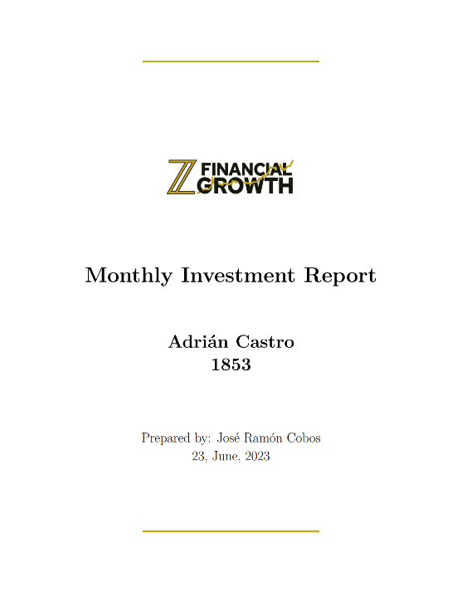The main elements that can be found on the cover are: the corporate logo, again the logo of the startup Z Financial Growth,



the title of the document "Quarterly Investment Report", the name of the corresponding investor, the Investor Identifier or "ID", the name of the person who has prepared the report and the date. All of this information is within two lines of the startup's corporate color, #C7A61F.

3.2.4 Executive Summary: The second and the third page of the report is the Executive Summary. In this section, it explains to the investor what it means to invest in Z Financial Growth and specifies that the document you are reading provides an overview of the performance of your individualized portfolio and the changes that have taken place during the last quarter. This section is divided into: Investment Summary and Portfolio Holdings.

Investment Summary: In this section we find the following points.

* Introduction: The introduction sets the context for the investment report and establishes the timeframe. It highlights Z Financial Growth's focus on managing client capital, with a specific emphasis on cryptocurrency investments. This section conveys the firm's commitment to long-term prospects, indicating a strategic approach rather than being swayed by short-term price fluctuations. It is essential to mention the focus on cryptocurrencies in the introduction, as it helps clients understand the specific areas of expertise and investment strategies employed by Z Financial Growth.
* Investment philosophy: The investment philosophy outlines the core principles and values that guide Z Financial Growth's investment decisions. Here, it's mentioned that the firm supports blockchain-based companies with strong fundamentals, innovative technology, and profitable ecosystems. By prioritizing projects that bring tangible value to users and stakeholders, Z Financial Growth emphasizes a data-driven and long-term perspective. This philosophy reflects a deep understanding of the importance of fundamental analysis and the potential for transformative solutions in the cryptocurrency landscape.
* Thorough analysis: this part highlights the rigorous analysis conducted by Z Financial Growth before making investment decisions. The mention of factors such as technology, market demand, and adaptability showcases the comprehensive due diligence process undertaken by the firm. By emphasizing the importance of careful evaluation, Z Financial Growth positions itself as a meticulous and informed investment fund. This commitment to thorough analysis ensures that investment choices are grounded in solid research and assessment, increasing the likelihood of successful outcomes
* Commitment to the future: This section underscores Z Financial Growth's dedication to its investment philosophy and long-term growth strategies. By emphasizing patient and prudent investments in projects shaping the future of blockchain technology, the firm aligns itself with the broader industry advancements. This commitment not only reassures clients but also demonstrates Z Financial Growth's active involvement in driving positive change within the blockchain ecosystem. It positions the firm as a forward-thinking player with a vision for the future.
* Conclusion: The conclusion of the Investment Summary summarizes the key points presented earlier. By restating the criteria for project selection—strong fundamentals, innovative technology, and potential for profitable ecosystems—Z Financial Growth reinforces its

investment principles. Additionally, it emphasizes the thorough analysis undertaken and the unwavering commitment to shaping the future of blockchain technology. The conclusion serves as a call to action, assuring clients that their financial endeavors are in capable hands.



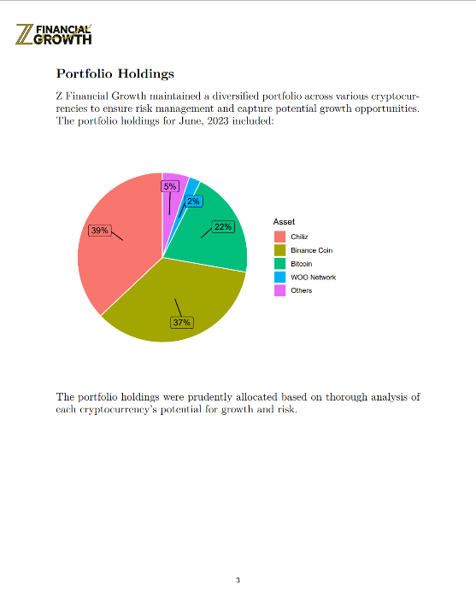Portfolio Holdings: This section showcases the top four assets with the highest allocation through a pie chart, offering a concise and intuitive snapshot of the portfolio composition. By presenting the data in a visually appealing manner, the pie chart allows readers to quickly grasp the relative proportions of the different assets in the portfolio. This visual representation enhances the readability and accessibility of the investment report, enabling clients and stakeholders to gain valuable insights into the diversification and concentration of their investments. Furthermore, the inclusion of a pie chart in the Portfolio Holdings section adds a layer of transparency and clarity to the report, facilitating effective communication and decision-making. Investors can easily identify the assets that contribute significantly to the overall portfolio value, enabling them to assess the potential risks and rewards associated with their investment positions.



3.2.5 Investment Overview: The fourth page of the report is the Investment Overview. This section provides an overview of the investor's historical financial data since they began investing in Z Financial Growth. This section is further divided into two sections; Portfolio Summary and Overview Per Asset.

Portfolio Summary: It includes the most important information of all, the general results of the portfolio, it is necessary that this information appears in a clear, transparent and simple way since it must be understandable by all audiences, whether or not they have knowledge in the field of finance. This section shows: the initial investment, the total withdrawals, the present value of the portfolio and the total result (Withdrawals + Present Value - Initial Investment). In this way everyone can know the results of their portfolio in a general way.

Overview Per Asset: It includes general information on the four most allocated assets in the portfolio (the same ones that appear in the portfolio allocation pie chart), only information on the most important assets is included so as not to overload the investor with information that is not relevant. This section shows metrics such as the value of the assets in the market, the total amount of assets held by the investor, the total dollar value of the assets held, the change in price in the last quarter and the allocation it represents over the total portfolio.

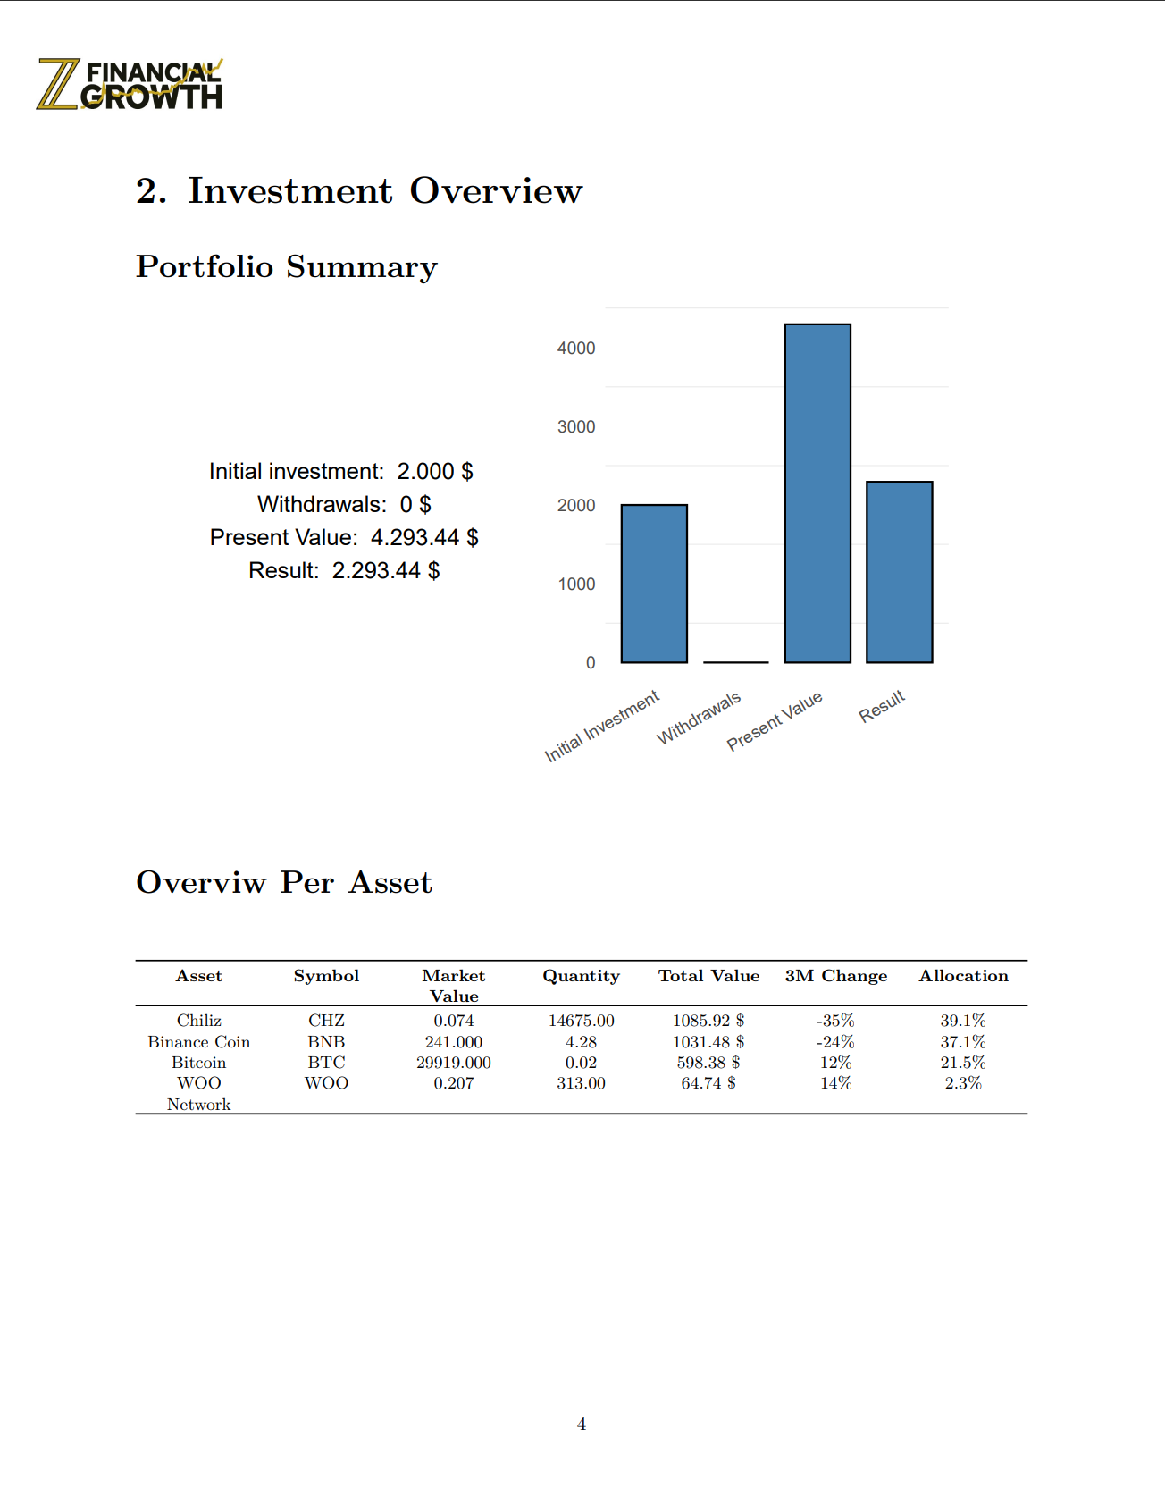

3.2.6 Investment Per Asset – Detailed Historical Data: The last 4 pages include more detailed and technical information about the most representative assets of the portfolio, each page includes one asset. In this section, investors have access to metrics that define the historical performance of the portfolio, such as, for example:

- Average Return: Average return of the asset historically

- Variation: Average Variation of the asset historically

- Deciles: Deciles divide the historical asset performance into ten equal parts. They show how the asset's performance varies at different levels, from the lowest return (the highest loss) to the highest return (the highest gain). It helps us to understand the range of returns and to identify periods of good or bad performance, as well as whether an asset's behaviors are within the normal range or excessively abnormal.

- Density: Visualizes the frequency of different return values for an asset over time. It helps understand the distribution of returns, identifying patterns and variability. It provides a snapshot of the asset's historical performance and risk characteristics.

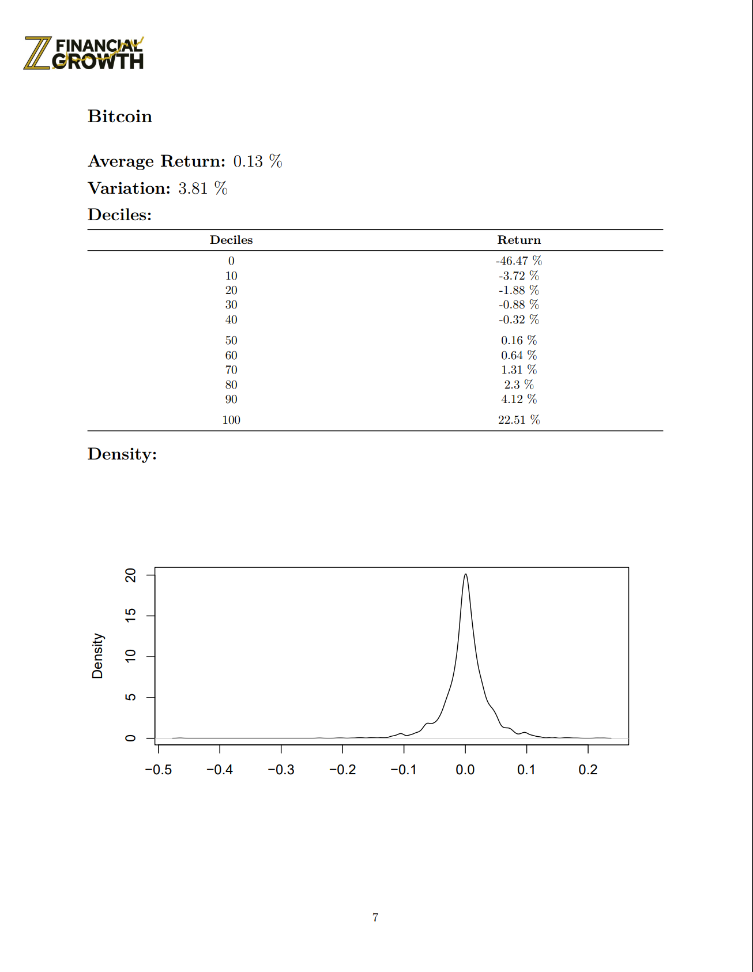

**Section 3.3 Parameterized Execution Loop**

The objective of the R script is to automate the generation of quarterly investment reports for multiple investors. The script follows a parameterized execution loop, where it iterates over a list of investor IDs and performs the following tasks for each investor:

1. Set the investor ID and current month/year in the R Markdown file: The script creates a list called params that holds the investor ID, current month, and current year. These parameters are used to personalize the generated reports for each investor.
2. Render the R Markdown file with the parameters: The rmarkdown::render() function is used to process the R Markdown file. The params list is passed as an argument to the render() function, allowing the R Markdown file to access and utilize the investor-specific information.
3. Create a unique filename: To differentiate the reports for each investor, the script retrieves the investor's name and last. It then constructs a unique filename by combining the investor's name, last name, current month, and current year.
4. Copy the rendered file to the desired location with the unique filename: The file.copy() function is used to copy the rendered report file from the source path to the destination path.

**Chapter 4 Future Enhancements and Challenges**

The development of an automated investment reporting solution marks a significant milestone in streamlining and simplifying the generation of quarterly investment reports. However, as with any software system, there is always room for improvement and anticipation of potential challenges. In this section, we explore the future enhancements and challenges that lie ahead in the continuous evolution and optimization of the solution.

Future Enhancements:

To maximize the effectiveness and value of the automated investment reporting solution, several areas can be targeted for future enhancements. These enhancements aim to improve the overall functionality, customization capabilities, performance, security, and scalability of the solution. By addressing these areas, the automated reporting system can become more adaptable, efficient, and reliable.

Challenges:

Identifying and understanding the challenges associated with the current solution is crucial for its continuous improvement. These challenges encompass various aspects, such as data quality and consistency, performance optimization, error handling and exception management, integration with external systems, and scalability and extensibility. By recognizing these challenges, proactive measures can be taken to overcome them and ensure the long-term success of the automated investment reporting solution.

**Section 4.1 Identified Limitations and Challenges:**

- Data Quality and Consistency: The article (Masooma Memon, 2023) explains that ensuring the quality and consistency of data is vital for generating accurate investment reports. Data quality issues, such as missing or incorrect data, or any of the other problems mentioned in the article, can pose challenges. Incomplete or inaccurate data can lead to misleading analysis and unreliable reports. Therefore, implementing data validation techniques, data cleansing processes, and data governance strategies will be essential to improve data quality and ensure consistent and reliable reporting.

- Customization and Adaptability: While the developed R program provides customization options (see chapter 5 User Guidance), there may be instances where specific user requirements are not adequately met. The ability to tailor the reporting templates, layouts, and visualizations to suit individual preferences or company branding is crucial. Enhancing the customization capabilities of the solution will enable users to generate reports that align with their unique needs and preferences.

- Performance Optimization: As the volume and complexity of data increase, the performance of the automated reporting solution may be impacted. Processing large datasets or complex calculations within a reasonable time frame is essential to maintain efficiency. Exploring performance optimization techniques can significantly enhance the speed and efficiency of report generation.

- Error Handling and Exception Management:

Robust error-handling mechanisms are essential to handle unexpected situations and ensure the reliability of the reporting solution. When errors occur during data processing, it is important to provide informative error messages and handle exceptions gracefully. Strengthening error handling and exception management capabilities will help identify and resolve issues promptly, minimizing the risk of generating inaccurate reports.

- Integration with External Systems: Investment reporting often requires integration with external systems, such as data providers, portfolio management tools, or customer relationship management systems. Seamless integration with these systems is essential for obtaining accurate and up-to-date data for analysis and reporting. Developing standardized interfaces or APIs to facilitate smooth data exchange and integration between the automated reporting solution and external systems will enhance overall efficiency and accuracy.

- Scalability and Extensibility: As the demand for investment reporting grows, ensuring the scalability and extensibility of the solution becomes crucial. The solution should be able to handle increasing data volumes and accommodate new reporting requirements without sacrificing performance. Designing a modular and flexible architecture that allows for easy integration of additional features and functionalities will enable the solution to adapt to evolving business needs effectively.

**Section 4.2 Potential Future Enhancements**

- Advanced Data Analytics: Expanding the analytical capabilities of the automated investment reporting solution can provide deeper insights and more comprehensive analysis. Incorporating advanced data analytics techniques, such as predictive modeling, machine learning algorithms, or data mining, can enable the identification of trends, patterns, and anomalies in the investment data. This can help in making informed investment decisions and improving overall portfolio performance.

- Collaboration and Sharing Features: Enabling collaboration and sharing features within the automated reporting solution can foster better teamwork and communication among stakeholders. Allowing multiple users to collaborate on report generation, review, and approval can streamline the reporting process. Implementing features such as comment threads, document sharing, and version control can enhance collaboration and ensure smooth information exchange.

- Natural Language Generation (NLG): Integrating natural language generation capabilities into the reporting solution can automate the generation of textual narratives based on the investment data. NLG techniques can transform numerical data and analysis into coherent and human-readable narratives. This can save time and effort in manual report writing and enhance the overall readability and understandability of investment reports.

- User-Friendly Configuration and Documentation: Simplifying the configuration process and providing comprehensive documentation will improve the user experience and reduce the learning curve for new users. Providing intuitive configuration options, and offering detailed documentation and tutorials will facilitate easier adoption and usage of the reporting solution.

By focusing on these potential future enhancements, the automated investment reporting solution can be continually improved, providing users with advanced analytical capabilities, enhanced visualization, collaboration features, and ensuring compliance with risk assessment and regulatory requirements. These enhancements will contribute to a more comprehensive, user-friendly, and valuable reporting solution.

**Section 4.3 Advanced Data Visualization Techniques**

In the current implementation of the automated investment reporting program, the data visualization capabilities focus on basic charts and graphs to represent key investment metrics and performance indicators. However, there is ample room for incorporating advanced data visualization techniques to enhance the presentation and analysis of investment data. Here, we discuss some potential future enhancements in this area.

Interactive Visualizations: integrating interactive visualizations into the reports generated by the program can allow users to explore and interact with the data directly within the report. Interactive elements such as tooltips, zooming, panning, and filtering can provide a more engaging and insightful experience for users.

Heatmaps and Treemaps: Represent multidimensional data. Heatmaps can be used to display correlations, portfolio allocation, or performance across different sectors or asset classes. Treemaps can illustrate hierarchical structures, such as the allocation of assets within a portfolio or the composition of investment holdings.

Network Visualizations: Represent relationships between different entities, such as companies, market sectors, or investment products. Network visualizations can aid in identifying patterns, trends, and potential risks by visualizing connections and dependencies.

Time-Series Visualizations: Advanced time-series visualizations for comprehensive analysis of investment performance over time.

Integration with Machine Learning: Combine advanced data visualization techniques with machine learning algorithms to provide interactive visualizations that highlight patterns, anomalies, or predictive insights.

These advanced data visualization techniques have the potential to elevate the quality and depth of analysis provided by the investment reports generated through the package. By incorporating these enhancements, users can gain a more comprehensive understanding of their investments, identify trends and patterns, and make data-driven decisions more effectively.

However, it is important to note that implementing these advanced data visualization techniques may introduce additional challenges, such as data preprocessing or computational requirements. It is crucial to carefully evaluate and address these challenges during the development and refinement of the program.

**Chapter 5: User Guidance**

This section explains the steps to be followed by a user who wants to use Report_Generator, whether expert or inexperienced in the field of programming and more specifically with the R programming language.

The objective is that the user feels comfortable and does not find errors that he does not know how to solve when using Report_Generator.

Once downloaded the GitHub repository and have the files on the computer, the user must ensure that the database keeps the required format. That is, as explained in section 3.2.2 Data Input, an Excel file with the first sheet containing the investors' data and a second sheet containing the financial data of each of the investors, as follows:

- Investors: Each row represents an investor and each column a variable, which are: first name, last name, the amount withdrawn from the fund, investor ID, and initial amount invested.

Table 1: Investors Sheet

- TotalBalance: Each row represents an investor (identified with the ID) and by columns all the assets managed by the fund, for each investor, the amount of that particular asset.  
In addition a last column with the total value of those assets in the market.

Table 2: TotalBalance Sheet

This is necessary so that the data is read by the report_template document correctly and the report is developed properly.

Once the database complies with the format, the second step is to enter the necessary paths for the program to find and save the files correctly.

In the file report_generator:

1.- The path to the database in the excel_file variable.

2.- The path of the report_template file in the rmarkdown::render() function.

3.- The path where the file will be generated by default (the same directory where the report_template file is located) in the source_file variable.

4.- The path where the user wants the generated reports to be saved in the destination_file variable.

In the fil report_template:

1.- Assets to be shown in the report.

2.- The path of the corporate logo every time it appears:

  
  
(8 times total)

3.- The texts of the report.

**Bibliography**

Wickham, H. (2014). Tidy Data. Journal of Statistical Software, 59(10), 1-23. <https://www.jstatsoft.org/article/view/v059i10>

Xie, Y., Allaire, J. J., & Grolemund, G. (2018). R Markdown: The Definitive Guide. CRC Press.  
<https://bookdown.org/yihui/rmarkdown/>

Wickham, H., & Grolemund, G. (2017). R for Data Science. Retrieved from <https://r4ds.had.co.nz/>

Wickham, H., Averick, M., Bryan, J., Chang, W., McGowan, L. D., François, R., ... & Hester, J. (2019). Welcome to the tidyverse. Journal of Open Source Software, 4(43), 1686.   
<https://doi.org/10.21105/joss.01686>

Pedersen, T. L. (2021). ggraph: An Implementation of Grammar of Graphics for Graphs and Networks. R package version 2.0.5.   
<https://ggraph.data-imaginist.com/>

Kuhn, M. (2020). caret: Classification and Regression Training. R package version 6.0-86.   
<https://cran.r-project.org/web/packages/caret/index.html>

Kassambara, A. (2021). ggpubr: 'ggplot2' Based Publication Ready Plots. R package version 0.4.0.   
<https://cran.r-project.org/web/packages/ggpubr/index.html>

Neuwirth, E. (2014). RColorBrewer: ColorBrewer Palettes. R package version 1.1-2.  
<https://cran.r-project.org/web/packages/RColorBrewer/index.html>

Wickham, H. (2019). Advanced R. CRC Press.  
<https://adv-r.hadley.nz/>

Bengtsson, H. (2019). future: Unified Parallel and Distributed Processing in R for Everyone. Journal of Statistical Software, 79(1), 1-49.   
<https://doi.org/10.18637/jss.v079.i01>

Müller, K., & Wickham, H. (2021). Tibbles: A Data Frame for the 21st Century.  
<https://r4ds.had.co.nz/tibbles.html>

True Tamplin, (2023), Investment Performance Reporting  
<https://www.financestrategists.com/wealth-management/investment-management/investment-performance-reporting/>

Voon Hoe Chen & Phaik Sin Tay, (2023), Intelligent automation in financial reporting.   
<https://www.pwc.com/sg/en/risk-assurance/intelligent-automation-in-financial-reporting.html>

Zvi Korn, (2023), Why You Should Stop Creating Your Reports Manually  
<https://www.datarails.com/from-manual-reporting-to-automated-financial-reports/>

R on Curious Joe (2020), Automate Your Repetitive Reports!  
<https://www.r-bloggers.com/2020/01/automate-your-repetitive-reports/>

Alexandra Twin, (2022), Investment Analysis Explained: Definition, Types, and Importance  
<https://www.investopedia.com/terms/i/investment-analysis.asp>

Jeanne Boillet, (2020), How to make the most of AI corporate reporting  
<https://www.ey.com/en_gl/audit/how-to-make-the-most-of-ai-in-corporate-reporting>

Clare McKinley, (2022), What is automated reporting?  
<https://basis.com/blog/what-is-automated-reporting>

Garrett Grolemund, (2014), Introduction to R Markdown  
<https://rmarkdown.rstudio.com/articles_intro.html>

Masooma Memon, (2023), 10 Common Data Quality Issues in Reporting and Best Practices to Overcome Them.  
<https://databox.com/data-quality-issues-in-reporting#why>

GitHub Repository: <https://github.com/RialPepe/Report_Generator>